**Walchand College of Engineering, Sangli Department of Computer Science and Engineering**

**Practical No. 2**

**To install and configure Node.js server and IDE.**

**PRN NO:2018BTECS00042**

**NAME: Pooja Vishnu Shinde**

# Problem Statement 1:

1. Create a separate workspace for your project using selected IDE.

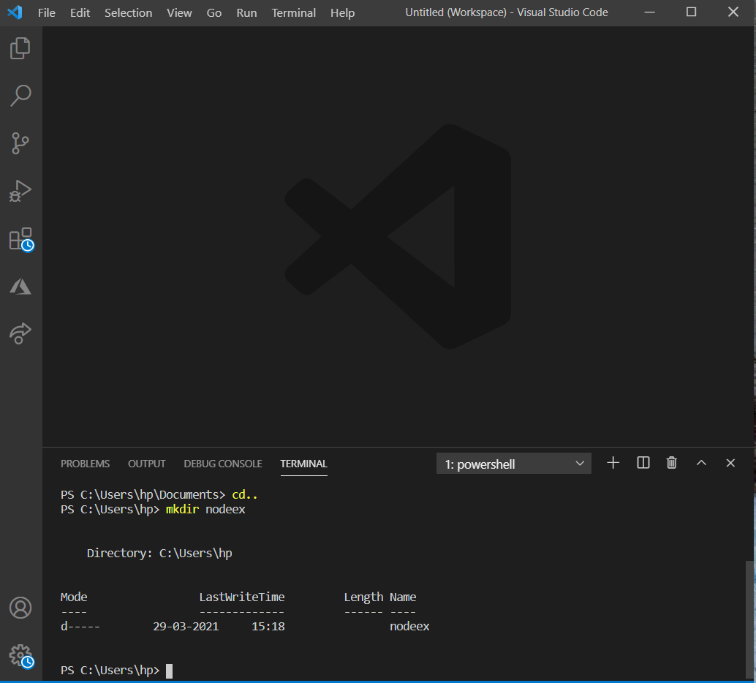

1. Write a program to start a Node.js server on localhost and listens to the client requests on port number 8080.

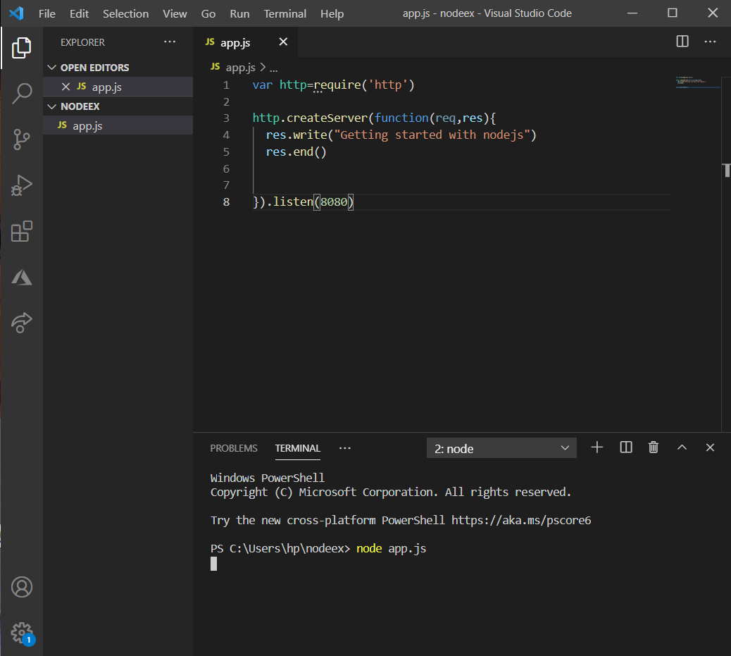

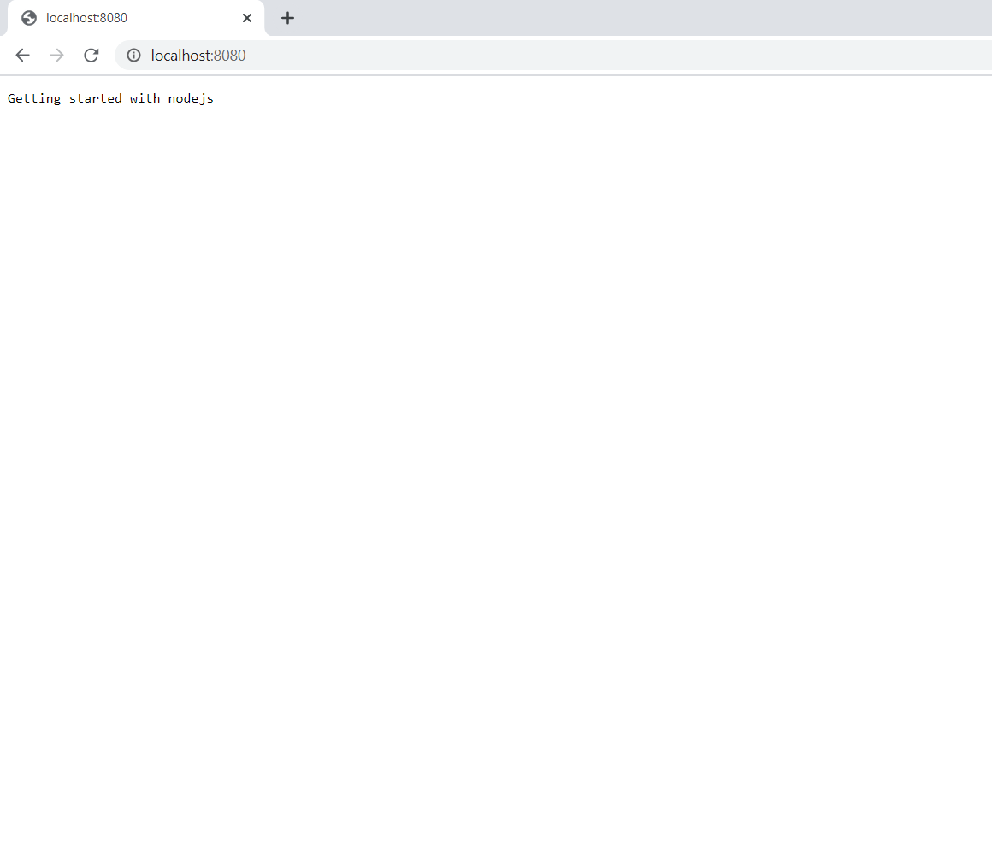

1. Change the Node.js IP address and port number and start the server again.

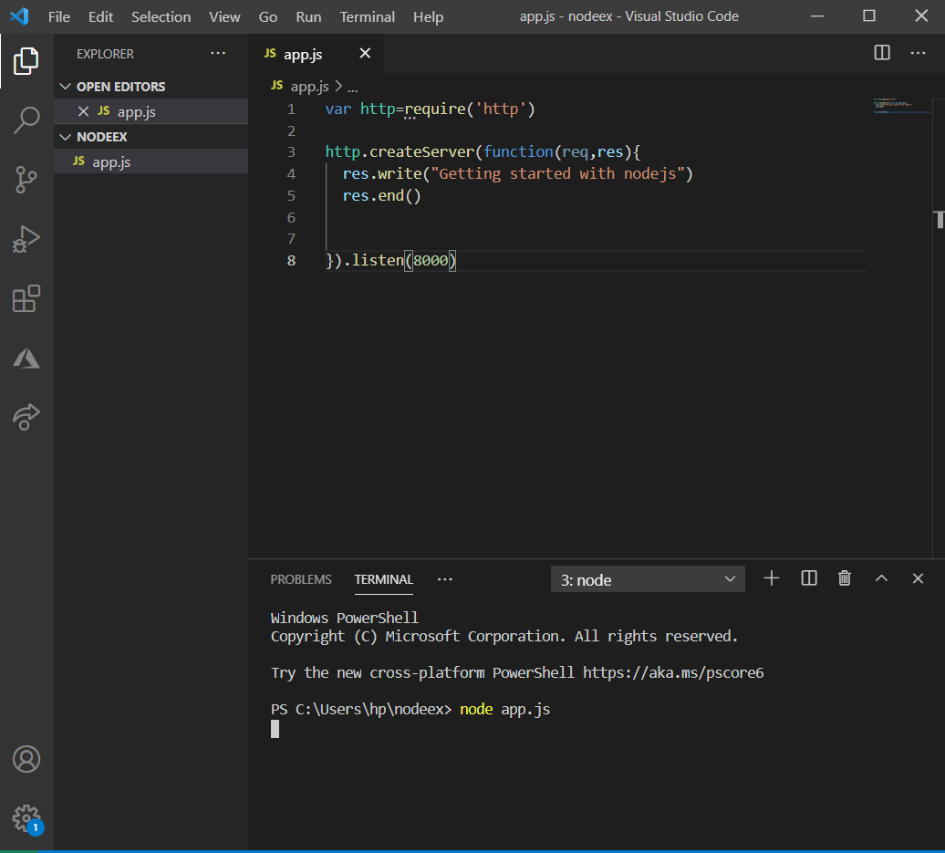

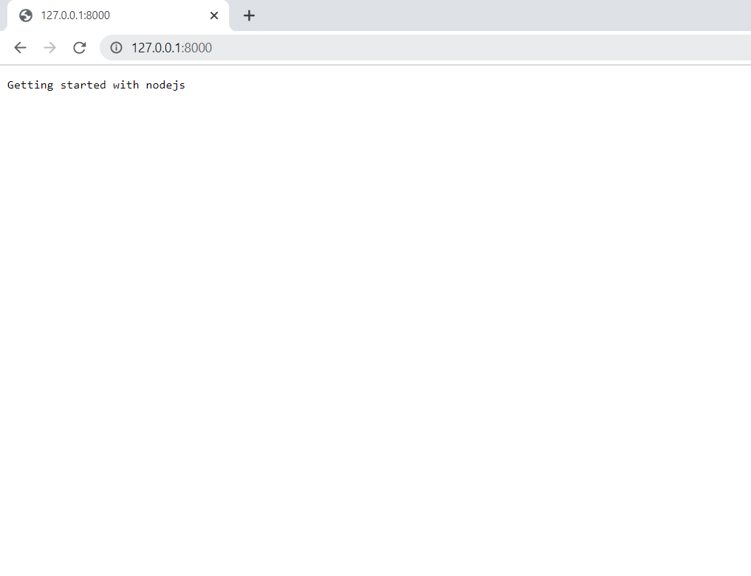

# Problem Statement 2:

1. Perform the fundamentals programming constructs such as operations, loops, variable assignments and printing their values using Node.js REPL environment

**REPL (READ, EVAL, PRINT, LOOP)** is a computer environment similar to Shell (Unix/Linux) and command prompt. Node comes with the REPL environment when it is installed. System interacts with the user through outputs of commands/expressions used. It is useful in writing and debugging the codes. The work of REPL can be understood from its full form:

**Read** : It reads the inputs from users and parses it into JavaScript data structure. It is then stored to memory.  
**Eval** : The parsed JavaScript data structure is evaluated for the results.  
**Print** : The result is printed after the evaluation.  
**Loop** : Loops the input command. To come out of NODE REPL, press **ctrl+c** twice

**Getting Started with REPL:**  
To start working with REPL environment of NODE; open up the terminal (in case of UNIX/LINUX) or the Command prompt (in case of Windows) and write **node** and press ‘enter’ to start the REPL.

**Getting Started with REPL:**  
To start working with REPL environment of NODE; open up the terminal (in case of UNIX/LINUX) or the Command prompt (in case of Windows) and write **node** and press ‘enter’ to start the REPL.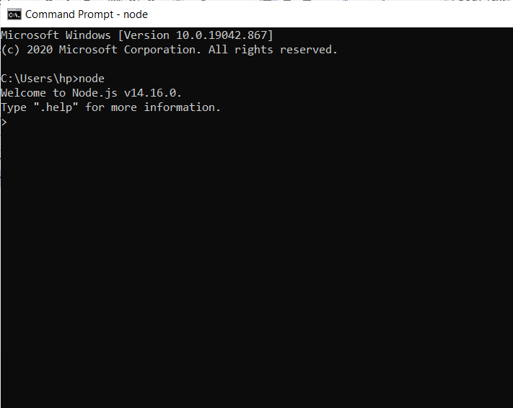

**Example:** Performing Arithmetical operations in REPL

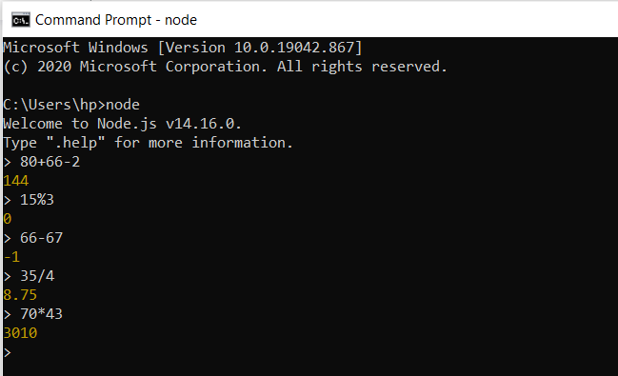

**Example:** Performing operations using libraries of NODE.

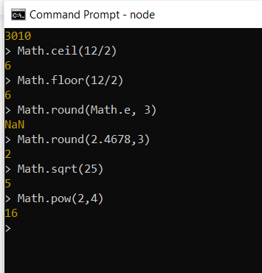

**Example:** Using variables in REPL. The keyword **var** is used to assign values to variables.

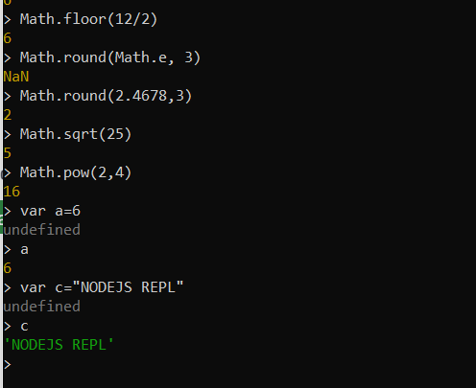

**Example:** Using **loops** in REPL. Loops can be used in REPL as in other editors.

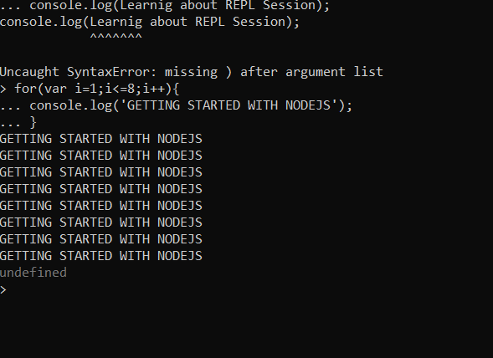

1. Save the REPL session to a file and reload the REPL session.

